General Information
PICTURE | 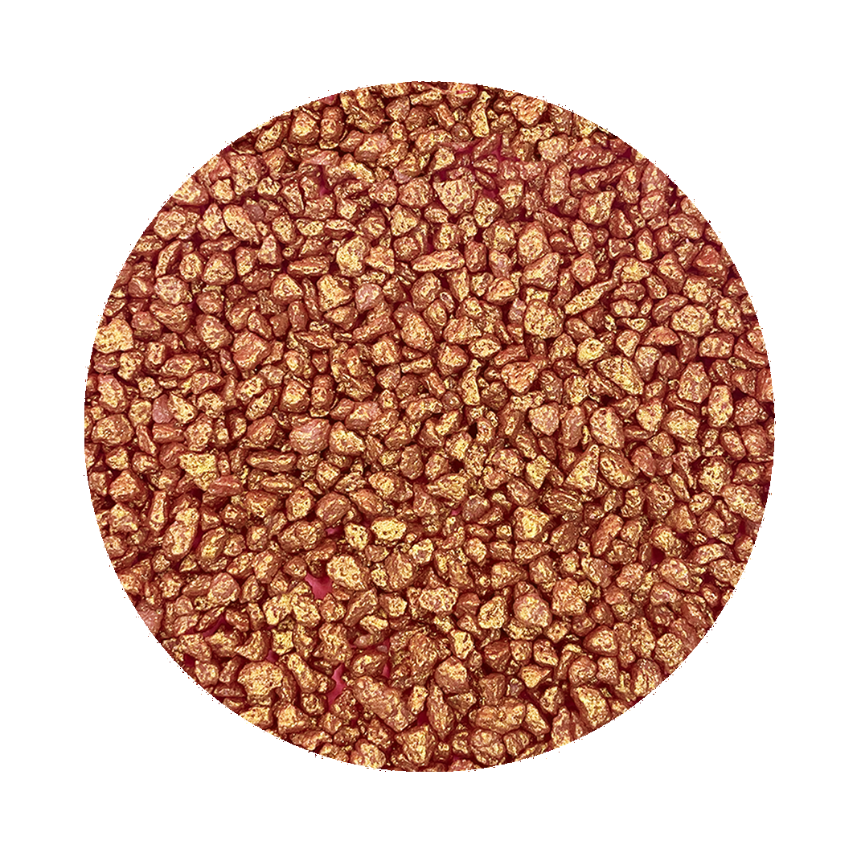
DESCRIPTION | Gold Glitter Coated, Cocoa Butter Coated, Sugar Nibs
SKU CODE | SPR-GGSN
SPEC NUMBER | SP0038
LEGAL DECLARATION when used in isolation according to EU regulation 1333/2008 & Commission directives 231/2012 & 1129/2011 | Sugar Confectionary
INGREDIENT DECLARATION | Sugar, Cocoa butter, Glitter (Potassium Aluminium Silicate (E555), Diiron Trioxide (E172)).
RAW MATERIAL COUNTRY OF ORIGIN | UK, China, Other locations may be possible.
COUNTRY OF MANUFACTURE | UK
SHELF LIFE & STORAGE INSTRUCTIONS | 12 Months, Store in the dark at 10°C to 20°C and protect from the extremes of temperature.
APPLICATIONS | Confectionary, Bakery, Desserts, ETC.
DOSAGES RECOMMENDED | Dependant on application

Microbiological Limits
TEST | MAX LIMIT |  | FREQUENCY OF TESTING
TVC | 10,000 Cfu/g |  | Tested on a random sample basis
Yeasts | 100 Cfu/g |  | Tested on a random sample basis
Moulds | 100 Cfu/g |  | Tested on a random sample basis
Enterobacteriaceae | Not tested |  | NA
E Coli | Not tested |  | NA
Salmonella | Negative in 25g |  | Tested on a random sample basis
Coliforms | Not tested |  | NA
Listeria | Not tested |  | NA

Organoleptic and Quality

Product Characteristic
Sparkly, Sweet.

Foreign Body Controls e.g.Metal Detector/X-Ray/Sieve

Control Type | Detection limit | Frequency
Metal Detection | 2.5mm Ferrous | Every Batch

Physical Properties

Physical Property | Limit | Testing Frequency
PH | NA | NA
AW | NA | NA
Moisture | NA | NA
Ethanol Content | NA | NA

Nutritional Information per 100g
Energy | 1848.10 | KJ
Energy | 436.07 | Kcal
Carbohydrate | 89.21 | g
Of which sugars | 89.29 | g
Fat | 8.93 | g
Of which saturates | 5.33 | g
Protein | 0 | g
Fibre | 0 | g
Salt | 0 | g

Allergen Information

Does the product contain any of the following, including any possible source of cross contamination or carry over?
Allergen (Directive EU 1169/2011 Annex II) | Present in Product | Used on site | Used on Shared Equipment | Risk of contamination (Y/N)
Cereals containing gluten, namely: wheat, rye, barley, oats, spelt, kamut or their hybridised strains, and products thereof, except:  - wheat based glucose syrups including dextrose  - wheat based maltodextrins  - glucose syrups based on barley;  - cereals used for making alcoholic distillates including ethyl alcohol of agricultural origin; | N | Y | N | N  (Used on site in finished goods, packed using separate dedicated equipment)
Crustaceans and products thereof | N | N | N | N
Eggs and products thereof | N | Y | N | N  (Used on site in finished goods, packed using separate dedicated equipment)
Fish and products thereof, except:  - fish gelatine used as carrier for vitamin or carotenoid preparations;  - fish gelatine or Isinglass used as fining agent in beer and wine; | N | N | N | N
Peanuts and products thereof; | N | N | N | N
Soybeans and products thereof, except  - fully refined soybean oil and fat  - natural mixed tocopherols (E306), natural D-alpha tocopherol, natural D-alpha tocopherol acetate, and natural D-alpha tocopherol succinate from soybean sources;  - vegetable oils derived phytosterols and phytosterol esters from soybean sources  - plant stanol ester produced from vegetable oil sterols from soybean sources; | N | Y | N | N  (Used on site in finished goods, packed using separate dedicated equipment)
Milk and products thereof (including lactose), except:  - whey used for making alcoholic distillates including ethyl alcohol of agricultural origin;  - lactitol; | N | Y | N | N  (Used on site in finished goods, packed using separate dedicated equipment)
Nuts, namely  almonds (Amygdalus communis L.), hazelnuts (Corylus avellana), walnuts (Juglans regia), cashews (Anacardium occidentale), pecan nuts (Carya illinoinensis (Wangenh.) K. Koch), Brazil nuts (Bertholletia excelsa), pistachio nuts (Pistacia vera), macadamia or Queensland nuts (Macadamia ternifolia), and products thereof, except:  - Nuts used for making alcoholic distillates including ethyl alcohol of agricultural origin | N | N | N | N
Celery and products thereof | N | N | N | N
Mustard and products thereof | N | N | N | N
Sesame seeds and products thereof | N | N | N | N
Sulphur dioxide and sulphites at concentrations of more than 10 mg/kg or 10 mg/litre in terms of the total SO₂ which are to be calculated for products as proposed ready for consumption or as reconstituted according to the instructions of the manufacturers | N | N | N | N
Lupin and products thereof | N | N | N | N
Molluscs and products thereof | N | N | N | N

Intolerance Information

Does the product contain any of the following, including any possible source of cross contamination or carry over?
INTOLERANCE SUBSTANCES: | Y/N | If yes, give details
Aspartame | N
Additives (E’ Numbers etc) | Y | E555, E172
Beef and beef derivatives | N
Benzoates | N
BHA/BHT | N
Chicken and chicken derivatives | N
Cocoa | Y | Cocoa Butter
Coriander | N
Fruit and fruit derivatives | N
Glutamate | N
Legumes and Pulses | N
Monosodium Glutamate (MSG) | N
Pork and pork derivatives | N
Synthetic Colours including Azo and Coal tar dyes | N
Vegetable and Vegetable derivatives | N
Vegetable Oil:  If yes state type and source, eg. Hydrogenated, partially hydrogenated: rapeseed, peanut, etc. | N
Yeast and yeast derivatives | N

Suitability

 | Y/N | If not, give details
Vegetarians | Y
Vegans | Y
Orthodox Jewish Diet (Kosher) | y | (Not Certified)
Muslim Diet (Halaal) | Y | (Not Certified)
Diabetics | N | High Sugar Content

Genetically Modified Organisms (GMO)

 | Y/N | Details
Does the product or any of its ingredients contain any maize or soya products? | N
Does the product or any of its ingredients contain any genetically modified material (whether active or not)  Please identify ingredients which contain such materials | N
Is the product or any of its ingredients not substantially equivalent as a consequence of the use of genetic modification?  Please identify any such ingredient | N
Is the product or any of its ingredients produced from, but not containing any genetically modified material?  Please identify those ingredients, which are produced from such materials. | N
Have genetically modified organisms been used as processing aids or additives used in connection with the production of these ingredients?  Please identify any such processing aids or additives | N
Have genetically modified organisms been used to produce processing aids or additives (GMO not present in aid or additive when in use) which are subsequently used in production of this product or any of its ingredients?  Please identify any such processing aids or additives. | N

Irradiation

Has the product or any of the ingredients including processing aids been treated with ionising radiation | No

Pesticides

Pesticide residue tested for | Maximum limit | Frequency
Not Tested | NA | NA

Heavy Metals

Test | Maximum limit | Frequency
Not Tested | NA | NA

Mycotoxins

Test | Maximum limit | Frequency
Not Tested | NA | NA

Additional Information

Packed into pouches, also available as a bulk item, in all cases packaging is suitable to the product

Sign off
I declare that the information detailed on this document is believed to be correct as of the date specified below.
This product and data comply with all current UK and EU regulations.
This specification is deemed accepted by both parties if no issues have been reported to the supplier within one week.
Supplier |  | Customer
Name | Richard Strauss | Name
Position | Technical Manager | Position
Date | 20/09/2023 | Date
Signature |  | Signature

